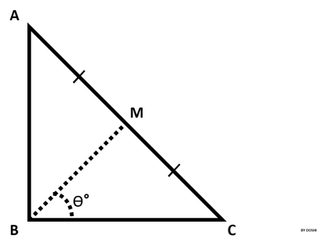 ABC is a right triangle, 90 degree at B.

Therefore, angle ABC = 90.

Point M is the midpoint of hypotenuse AC.

You are given the lengths  and .  
Your task is to find  angle MBC in degrees.

**Input Format**

The first line contains the length of side AB.  
The second line contains the length of side BC.

**Output Format**

Output angle MBC in degrees.

**Note:** Round the angle to the nearest integer.

**Examples**:  
If angle is 56.5000001°, then output **57°**.  
If angle is 56.5000000°, then output **57°**.  
If angle is 56.4999999°, then output **56°**.

**Sample Input**

10

10

**Sample Output**

45°